**PhonePe Transaction Insights**

**📄 Problem Statement: PhonePe Transaction Insights Dashboard**

This project is a **data visualization dashboard** built using **Streamlit, Plotly, and Pandas.It analyzes and visualizes **PhonePe transaction data** across Indian states with interactive charts and maps.The main objective of the project is to provide insights into **transaction trends, distributions, and regional comparisons** through an easy-to-use web application.**`**

**1. Introduction**

Digital payments in India have seen exponential growth, driven by platforms like **PhonePe**, which enable seamless financial transactions. Analyzing these transaction patterns can provide valuable insights into **user behavior, transaction distribution, and market penetration across different states**. However, there is a lack of interactive, visual, and real-time dashboards that allow stakeholders to explore this data effectively.

**2. Problem Definition**

Currently, transaction data is available in raw form but is difficult to interpret due to the following challenges:

* **Lack of Visualization:** Raw CSV and JSON data do not provide clear insights without proper visualization.

* **Geographical Complexity:** Understanding state-wise distribution requires geospatial mapping.

* **Decision-Making Gap:** Businesses, policymakers, and researchers struggle to derive actionable insights without an intuitive interface.

Thus, there is a need to build a **Streamlit-based interactive dashboard** that visualizes PhonePe transaction insights across Indian states using **maps, charts, and filters**.

**3. Objectives**

* To build a **data visualization dashboard** using Streamlit.

* To integrate **India GeoJSON maps** for state-level transaction analysis.

* To provide **interactive filters** (Year, State) for customized insights.

* To represent insights through **metrics, choropleth maps, bar charts, and pie charts**.

* To enable **decision-making support** for stakeholders like businesses and analysts.

**4. Scope of the Project**

* **In-scope**:

* Visualization of state-wise transaction distribution.

* Representation of total, average, and comparative transaction amounts.

* User-friendly interface with Streamlit.

* **Out-of-scope**:

* Real-time live API integration from PhonePe (due to restrictions).

* User authentication and payment gateway functionality.

**5. Expected Outcomes**

* An **interactive dashboard** where users can explore PhonePe transaction patterns.

* **Geospatial representation** of transactions on India’s map.

* **Comparative insights** via bar charts and pie charts.

* A structured way to analyze **digital payment trends across states**.

---

⚡ This document can serve as the **Problem Statement section** in your final year project report.

👉 Do you want me to also prepare a **separate "Project Objectives & Deliverables" section** that you can attach right after this in your report?

**Additionally added the features:**

### **1. Decoding Transaction Dynamics on PhonePe**

The leadership team seeks a deeper understanding of these patterns to drive targeted business strategies.

#### **2. Device Dominance and User Engagement Analysis**

PhonePe aims to enhance user engagement and improve app performance by understanding user preferences across different device brands.

**3. Insurance Penetration and Growth Potential Analysis**

PhonePe has ventured into the insurance domain, providing users with options to secure various policies..

#### **4. Transaction Analysis for Market Expansion**

PhonePe operates in a highly competitive market, and understanding transaction dynamics at the state level is crucial for strategic decision-making.

**5. User Engagement and Growth Strategy**

PhonePe seeks to enhance its market position by analyzing user engagement across different states and districts.

**Objective for phonepe**

**“PhonePe Transaction Insights Dashboard”** (using Streamlit, Pandas, Plotly, and GeoJSON for India maps), here’s a clear **objective** you can include in your report:

**🎯 Project Objective**

The main objective of this project is to **analyze and visualize PhonePe transaction data** across different states of India, enabling better understanding of digital payment trends. The project aims to:

1. **Provide interactive dashboards** for exploring transaction patterns across Indian states.

2. **Visualize transaction amounts geographically** using choropleth maps for state-level comparisons.

3. **Offer statistical insights** such as total transactions, average transaction per state, and number of states involved.

4. **Enable state-wise and year-wise filtering** of data for customized analysis.

5. **Compare states through charts** (bar chart, pie chart) to highlight distribution and growth trends.

6. **Present raw data tables** for detailed examination of underlying records.

**🎯 Advantages of phonepe Project**

**1.Interactive Dashboard**

* Built using **Streamlit**, so it’s easy to use and doesn’t require advanced coding to interact with.

* Sidebar filters let users explore by state and year dynamically.

**2. Clear Visualizations**

* Choropleth Map: Shows transaction amounts across India with geographical context.

* Bar Chart**: Compares state-wise totals for quick ranking.

* Pie Chart**: Displays distribution of transactions, highlighting major contributors.

**3. Data Insights at a Glance**

* Displays total transactions, average per state, and number of active states** using `st.metric`.

* Helps stakeholders quickly understand transaction trends without digging into raw data.

**4. Real-time & Scalable**

* Fetches data dynamically from an online CSV and GeoJSON — so it can easily be updated with live PhonePe datasets.

* Works well for larger datasets if needed.

**5.Educational Value**

* Demonstrates integration of multiple Python libraries:

* Streamlit** (dashboard/UI)

* Pandas** (data manipulation)

*Plotly** (interactive visualizations)

* Requests/JSON** (handling GeoJSON data)

**6. Practical Use Case**

* Can be used by financial analysts, businesses, or policymakers to understand digital payment adoption** across regions.

* Useful for market expansion strategies (which states have low/high adoption).

**7. User-Friendly & Lightweight**

* Runs in a browser, no complex setup needed.

* Provides both **visual + raw table preview**, making it useful for both analysts and general users.

**Technologies Used**

* **Python 3.9+**

* **Streamlit** – for building the dashboard interface

* **Pandas** – for data manipulation

* **Plotly Express** – for creating interactive charts and maps

* **Requests & JSON** – for fetching and processing geojson/state boundary data

* **PyArrow** (used internally by Streamlit for dataframes)

**Features Implemented**

🔹 **Data Handling**

1. Fetches transaction data from an online **CSV dataset**.

2. Preprocesses the data (renaming columns, filtering states, etc.).

3. Loads **GeoJSON** data to enable Indian state-level mapping.

🔹 **Interactive Filters**

1. Sidebar with **multi-select filters** for:

2. State(s) * Year(s) (if available in dataset)

🔹 **Key Metrics**

1.Total Transaction Amount**

2.Average Transaction Amount per State**

3.Number of States Selected**

🔹 **Visualizations**

1. **Choropleth Map** – Transaction amount by state (color-coded on India map).

2. **Bar Chart** – State-wise transaction totals, sorted in descending order.

3. **Pie Chart** – Distribution of transaction amounts by state.

4. **Data Table** – Interactive preview of the filtered dataset.

**System Workflow**

**1. Data Loading:**

*CSV dataset is fetched using Pandas.

* State boundaries are fetched using GeoJSON.

**2. Filtering & Processing**

* User-selected states and years are applied.

* Data is aggregated for metrics and plots.

**3. Visualization**

* Plotly Express generates interactive charts.

* Streamlit displays them in a clean, interactive UI.

**4. Limitations**

* Currently uses a **sample dataset** (COVID active cases mapped as transactions).

* Yearly breakdown only works if dataset has `Year` column.

* Requires **internet connectivity** to fetch GeoJSON and CSV.

**5. Future Enhancements**

* Replace demo dataset with **actual PhonePe Pulse data**.

* Add **district-level analysis**.

* Implement **trend line charts** (monthly/quarterly).

* Export insights as **PDF/Excel reports**.

**Conclusion**

This project successfully demonstrates how **Streamlit + Plotly** can be used to create an **interactive dashboard for financial/transaction insights**.

It can easily be extended to real-world PhonePe data, providing businesses and analysts with powerful tools for **decision-making and regional analysis**.

### **▶️ How to Run the PhonePe Transaction Insight Dashboard**

### **Launch the Streamlit Dashboard**

**Run the app using: bash streamlit run pho.py 🌐 Open your browser and go to:** [**http://localhost:8501/**](http://localhost:8501/)

**Screenshot:**

**1.**

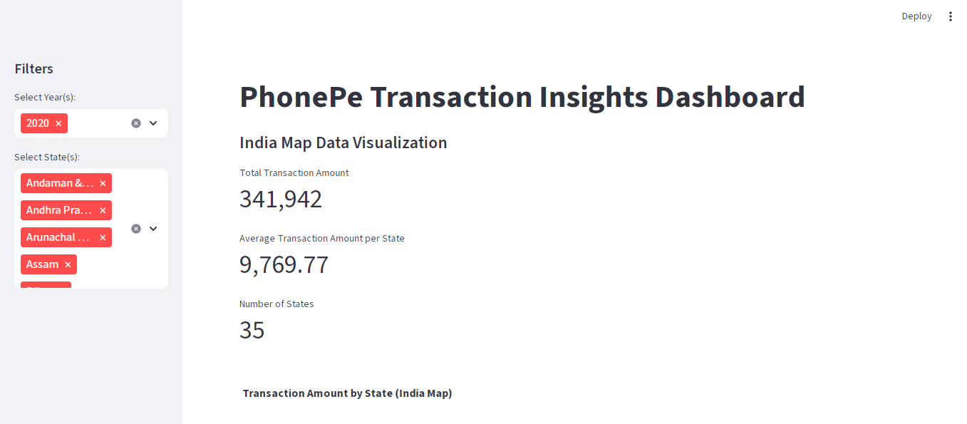

**2. Map Visualization 👍**

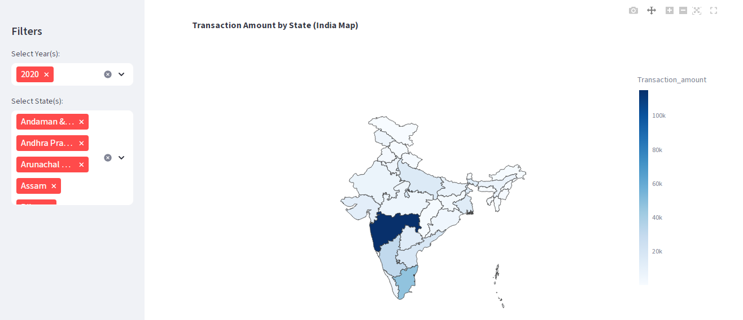

**3.state -wise transaction**

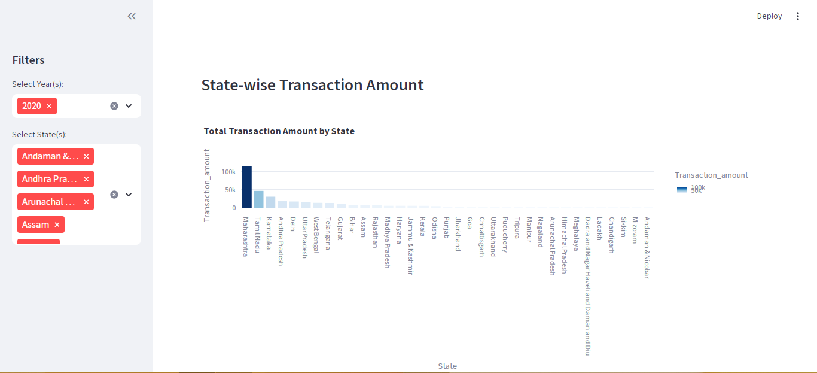

**4. Transaction distribution:**

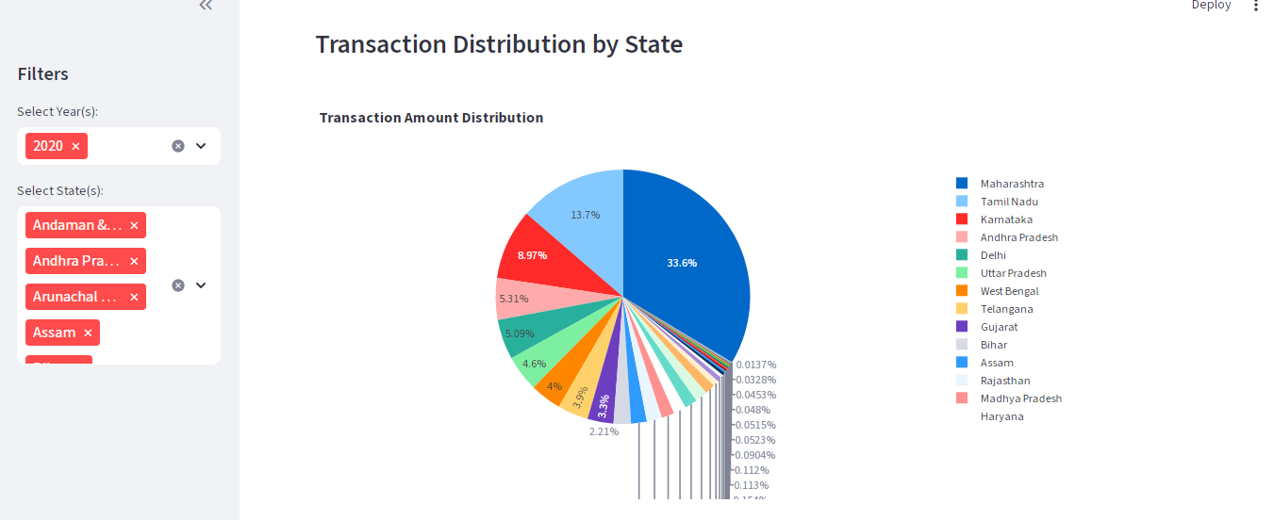

**5.Raw data preview:**



